A camera-trap survey investigating the use of pools by terrestrial mammals in the non-perennial Prins River system

by

**Ayesha Hargey**

**Student number: 3650393**

Mini-thesis submitted in partial fulfilment of the

requirements for the degree BSc. (Hons.) in

**Biodiversity and Conservation Biology**

**Supervisor: Prof. J A Day**

**Co-Supervisor: Dr. B Maritz and Dr M. Grenfell**

18 November 2019

Table of Contents

**Introduction** 3

Non-perennial rivers 3

Sampling animal communities 6

**Methods and Materials** 12

Study area 12

Survey design 15

Data analysis 18

# Introduction

## Non-perennial rivers

River systems in arid landscapes across the world that undergo intermittent cessation of water flow are known as non-perennial rivers. There exists a deficit in research towards these systems despite their abundance, as rivers that dry up occasionally make up more than half the river-length in South Africa as well as globally (Raymond *et al*., 2013, Day *et al*., 2019). Terminology used to describe these river systems is inconsistent, some authors using ‘intermittent’ (Datry, Larned and Tockner, 2014) and others ‘ephemeral’ (Matthews, 1988), among other terms, but all are ‘non-perennial rivers’. Unlike their perennial counterparts which are associated with a predictable nature, non-perennial rivers are complex, highly variable aquatic ecosystems impacted by changes in a mixture of standing water, flowing water and dry terrestrial riverbed (Uys and O’Keeffe, 1997; Day *et al*., 2019). This is because they are impacted by changes in flow regime that leave them periodically flooded or dry. Furthermore, they are affected by the pools of standing water which remain in them during dry periods (Day *et al.*, 2019). As a result of their variability, they are challenging systems for the terrestrial mammas dependent on the water contained within them (Jacobson, 1997) — as well as the researcher who studies this environment, leaving a noticeable gap in research to non-perennial rivers (Steward *et al*., 2012). Yet, they are very important to both people and wildlife living in the vicinity, providing the scarce resource of water in the dry surroundings (Day *et al*., 2019). In the same way that non-perennial rivers are difficult for certain mammalian species to live in, they are equally challenging to manage but this does not mean they should be underrepresented by policy-makers. Rivers that run dry should no longer be considered atypical, but rather, as being part of a global phenomenon.

Although non-perennial rivers in South Africa are significant in size and extent, these environments are largely ignored in research and in management (Uys and O’Keeffe, 1997; Datry, Arscott and Sabater, 2011). Climate change has adjusted flow regimes, and the lack of understanding regarding the ecological impacts of this has led to policies based on unverified assumptions (Uys and O’Keeffe, 1997). With an increase in predicted droughts as a result of the warming of the climate, an increase in the abundance of non-perennial rivers is expected as well as an increase in the duration over which they remain dry (Meehl *et al*., 2007). Consequently, this has the potential to heavily impact the fauna dependent on these rivers.

A river recharges itself with water, allowing the reconnection of populations of aquatic organisms in previously isolated pools, as well as flows of organic matter and nutrients (Steward *et al*., 2012). When the river dries up again, it can act as a corridor for the movement of terrestrial organisms (Sánchez-Montoya et al., 2016). Many dry riverbeds contain minimal trees, ensuring limited obstructions and making it favourable as a means of migration. Herbivorous mammals and many carnivores use dry rivers as means to trace remaining waterholes (Mills and Retief, 1984). Arid environments are typically associated with high daily temperatures and high evaporation rates. Compounded with water scarcity, this environment leaves a challenge for larger mammal species such as ungulates that cannot take refuge in shelters in the same way that smaller vertebrates can (Grenot, 1992). Furthermore, Grenot (1992) notes that evaporative heat loss is an essential component for the maintenance of homeothermy. This becomes relevant when considering the decrease in available water sources in arid areas. Many of the small-bodied vertebrate species found in this environment have limited potential to store body water and need to replenish their water intake frequently (Smit *et al*., 2019). Smit *et al*. (2019) also found that the probability of drinking is higher on hot days, and further predict that under climate change conditions, more species will rely on available surface water.

Non-perennial rivers have value to humanity. This environment has been described as a ‘linear oasis’ due to the vegetation inside these corridors being richer in retained organic matter than the surrounding habitat. In comparison to perennial rivers, there is no constant water flow which moves through the fertile soil (Kassas and Imam, 1954). Many carnivore species congregate along non-perennial river courses due to the higher density of herbivorous prey close to the river, and as a result some of these predators are considered residents of the area (Coetzee, 1970). Cattle have been observed frequently grazing on the plants along non-perennial river beds (Kassas and Girgis, 1964). Steward *et al*. (2012) states that there is a poorly researched but important ecotone represented by a river transcending from a habitat that is aquatic to one that is terrestrial and it is this ecotone is responsible for maintaining the diversity in species composition.

Of relevance to this study is the common trait of non-perennial rivers sustaining pools of water in the riverbed (Seaman et al., 2016). The pools tend to persist even when the rivers aren’t flowing, and are important as often they are the sole water source. Romer (1958) has even theorized that it was the drying of pools in non-perennial rivers which caused sufficient environmental pressure that led to the evolution of water-independent movement traits in vertebrates, allowing them to venture onto land. Furthermore, it is also theorized that resistance to desiccation in aquatic vertebrates evolved as a response to the drying out of pools (Williams, 2005). Thus, they have importance both today and historically.

Non-perennial river research is uncommon despite their prevalence around the world, and the unique microhabitats contained within and around them (Datry, Arscott and Sabater, 2011). Previous studies on the faunal component of non-perennial rivers are vastly skewed towards invertebrates, and among those, studies such as Sánchez-Montoya *et al.* (2018) and Chester and Robson (2011) are skewed towards those that are aquatic. There is a major bias in research towards research involving perennial river networks, and this becomes even more concerning when dry rivers are expected to increase as water abstraction and land use alteration changes the environment (Datry, Larned and Tockner, 2014). Thus, there is a need for further studies pertaining specifically to mammals within this important environment.

## Sampling animal communities

Worldwide, there is an increasing prevalence of camera trap usage to monitor and inventory terrestrial faunal assemblages, with particular emphasis on mammals (Cusack *et al*., 2015). Despite mammals being some of the most charismatic animals, it is difficult to study them in a non-invasive manner using traditional methods as they are frequently nocturnal, avoid human presence and are noted for their elusive nature (Gonthier and Castañeda, 2013). Furthermore, in the case of predators, physical handling can be difficult and their secretive habits and low densities can make detection difficult (Kauffman *et al.*, 2007). Despite the challenges associated with their observation, mammals play a significant role in the ecosystem. An example of such is their role in seed dispersal and predation, with grazers and browsers being important in the regulation of plant species populations (Redford, 1992). Their presence in the environment also mediates complex habitat dynamics (Terborgh *et al*., 2008). Camera traps can be seen as a valuable aid in documenting presence, assessing identity and estimating abundance of mammals, which are all factors to be considered in conservation actions (Cusack *et al.*, 2015). Remote camera traps can be used to inventory the presence of large mammals, frequently under environmental pressures such as habitat loss.

In an attempt to preserve the natural environment, there has been a consistent shift towards non-invasive sampling (Tobler *et al*., 2008). Camera traps can be used to collect data that would prove difficult to collect otherwise. Because past research involved time-consuming techniques (such as capturing live individuals) or resulted in detrimental environmental impacts (Kauffman *et al*., 2007), it is understandable that there is an effort to use methods that do not affect the natural habitat in a permanent capacity. Camera traps allow a remotely activated camera to take photographs of an area (Wong and Kachel, 2016). This technology has improved in quality and decreased in cost, and provides reliable evidence of species present (Tobler *et al*., 2008). For this reason, camera traps are seen as one of the best modern methods of data collection for many ecological disciplines. Photographs taken by camera traps can then be analyzed to calculate species richness in an area, which in turn can be used to compare diversity and, at a broader scale, used in conservation planning strategies, as the data obtained can be used to improve species distribution maps (Tobler *et al.*, 2008).

One of the ways in which camera trap surveys can be used is the process of capture-recapture. These techniques have been used to estimate population density of a target species, usually those that have individuals that can easily be identified, such as tigers (*Panthera tigris*) (Karanth and Nichols, 1998). This is useful, particularly in cases where the study species is elusive and would otherwise prove difficult to measure. Another use of the data gathered from camera trap surveys is species occupancy modelling which, along with estimating the probability of detection, uses presence-absence data to estimate the probability of occurrence, allowing estimation of the biodiversity of an area (Cove *et al*., 2013). These models have been continuously updated and refined, most notably by Tobler *et al*. (2015) which utilized data over multiple surveys, and was then able to estimate species presence with higher accuracy, as well as for species with minimal data. Models such as these are useful when camera trap effort is high, and can then be used to investigate patterns in community composition and distribution over long periods of time, an aspect that would be useful when attempting to investigate, as an example, the effects of climate change on a particular habitat. However, many camera trap studies cannot give absolute numbers of population of a given area. This is due to a limitation of camera trap data as it is difficult to distinguish between different individuals for many species. This would then affect the analysis as it would not be possible to discern between multiple or single visits by a particular organism (Kauffman *et al*., 2007). Tobler *et al*. (2008) investigated camera trap efficiency for rainforest mammals and found that the position of camera and area covered have little impact on survey results, as long as camera density is high and one accounts for variation in major habitat types.

In violation of traditional random sampling, camera traps are frequently placed at points that animals are thought to frequent, such as watering holes or trails (Cusack *et al.*, 2015). Thus, it is important to acknowledge the inherent bias in some studies. Cusack *et al.* (2015) did show, however, that given sufficient sampling activity, species richness can be ascertained and camera placement does not affect inferences made at a community level. This suggests that as long as a study encompasses a long enough time period, a level will reach at which the majority of the community will be accounted for, regardless of whether cameras were placed randomly or not.

Detection rates can vary between species (Mann *et al*., 2014). Camera trap placement is important when considering survey design, as different species favour different environments (Edwards, Gange and Wiesel, 2016). Designing camera trap surveys which increase probability of detection is ideal due to the naturally low populations of many species occurring in arid environments (Hayward, O’Brien and Kerley, 2007). While smaller mammals may prefer the safety of off-trail vegetation, it was found that certain carnivores are exclusively detected by cameras on trails (Edwards, Gange and Wiesel, 2016). If a particular species is targeted for study, placement is not the only factor that can influence detection. Certain surveys use bait, for example the use of a fish lure when detecting brown hyenas (*Hyaena brunnea*) (Thorn *et al.*, 2009). This technique is undesirable due to the risk of permanent habituation around the site, which would not reflect an accurate depiction of the environment (Balme, Hunter and Robinson, 2014). While baiting certainly has advantages in increasing detection, as well as individual identification, it is not without consequences. Those at the greatest risk are charismatic carnivores such as lions (*Panthera leo*), leaving them more vulnerable to activities that use bait stations, such as trophy hunting (Balme, Hunter and Robinson, 2014). However, Edwards *et al.* (2016) put forth the idea of water sources as “natural bait”, since typical arid environments lack this essential resource. An advantage of camera placement at natural water sources is that it comes with none of the detriments of introduced bait. Additionally Edwards *et al*. (2016) found that camera traps placed at a water source produced higher detection probabilities than cameras away from water sources, and that some animals, such as fox species (*Vulpes* and *Otocyon*), were not at all detected except at a water source. This shows the importance of including a water source when attempting to provide an inventory for an environment that includes one.

With this knowledge, the use of camera traps along a non-perennial river can provide a useful representation of the environment. There are, however, no known camera trap studies published on non-perennial rivers in South Africa.

The study site is within the Klein Karoo, and projections show that water demand will continue to increase for this area as well as South Africa as a whole (Maitre, Colvin and Maherry, 2009). This makes it an ideal location for one of the first studies on the mammalian wildlife component of a non-perennial river. The aim of this project is to investigate the use of pools by the terrestrial mammals of the Prins River. The objectives of this study are thus:

* Firstly, to establish an inventory of terrestrial mammals that occur along the Prins River
* Document the assemblages of terrestrial mammals that are directly and indirectly affected by the presence of pools
* Examining diurnal variation in detection of terrestrial mammals
* Furthermore, camera efficiency will be tested through the use of motion-triggered images and images taken at timed intervals
* Finally, the project aims to record the changes in fluctuations in surface-water availability and the effects of this on the detection of individual animals

This study will provide the first documented inventory of the mammals found at the non-perennial Prins River, taking place along three locations along the Prins River, along a gradient of pool water availability.

The study is a component of the research undertaken by the multidisciplinary Non-Perennial Rivers Research Programme, a project led by the Institute of Water Sciences that is concentrating on understanding the relationships between river flow, ecosystem characteristics and services provided by non-perennial rivers. This research can then be used to facilitate decision making and management of non-perennial rivers.

# Methods and Materials

## Study area

The area known as the Klein Karoo occurs in the Western Cape, South Africa (Figure 1). It is known for its semi-arid climate which is where three separate biomes (Fynbos, Succulent Karoo and Subtropical Thicket) meet (Mucina and Rutherford, 2011). This results in an ecosystem known for its ecological diversity and indeed, the Fynbos and Succulent Karoo biomes are recognized as global biodiversity hotspots (Driver *et al*., 2003). Despite the importance of this region, a legacy of mismanagement and poor agricultural practices has left the land exploited (Thompson *et al*., 2005). The nature of the arid environment means that water is a scarce resource, and indeed, important for further development (Thompson *et al*., 2005). Climate change is predicted to have an effect on the climate regime, with warmer temperatures predicted, as well as a predicted increase in rainfall in summer months and a decrease in winter months (Maitre, Colvin and Maherry, 2009).

The Prins River is a tributary of the Touws River, one that has persisting pools that are not frequently connected to the larger river network. There is a need to investigate the significance of these pools in supporting the faunal component as Jacobson (1997) noted that non-perennial water sources support certain animal species in arid environments. These pools subsist even when the river stops flowing, and are thus sources of water. The study site is known for variable summer rainfall, with major floods expected at unpredictable intervals. It has a low rainfall (100-250mm yr-1), mean summer temperatures >30°C and mean winter temperature of 4-8°C (Maitre, Colvin and Maherry, 2009). As identified by Maitre *et al*. (2009), there is a lack of information on water systems in the Klein Karoo.

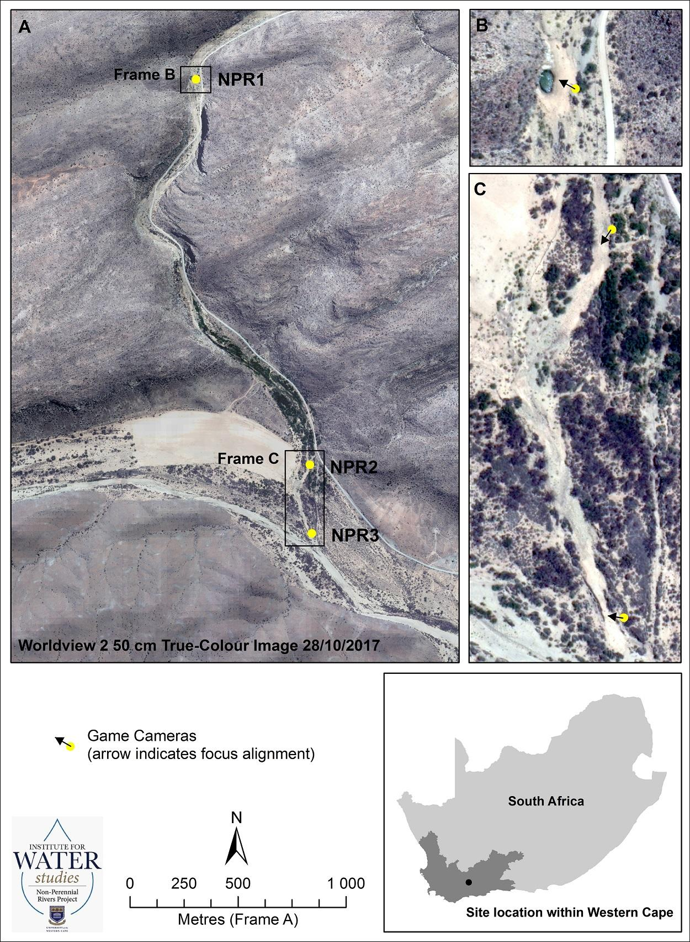

|  |
| --- |
| **Figure 1: Study area and location of camera trap stations, located along the Prins River, a tributary of the Touws River and showing the location of the Klein Karoo in South Africa (inset)** (Source: M Grenfell) |

## Survey design

A camera trap survey was carried out from 20th April 2017 to 21st June 2018 along the Prins River. It spanned 2.4km in total. Locations chosen were specifically targeted at naturally-occuring pools in the river. The survey included three sites, selected by the project coordinators and therefore beyond the control of this thesis project. The first camera (NPR1) was placed at a pool filled with water for the duration of the study (Figure 1, Frame B) , with the other two cameras (NPR2 & NPR3) situated at sites without perpetual water (Figure 1 Frame C). The total duration of the survey was 427 days. Bushnell cameras (Bushnell Outdoor Products, Overland Park, KS, USA) were set to capture photographs every hour, as well as whenever they were triggered by motion. Date, time and temperature were automatically stamped onto each photograph. After the first interval (Table 2), the camera at the permanent pool was set only to take photographs by motion-trigger.Cameras were operating 24 hours a day and batteries were checked and replaced three times over the course of the study.

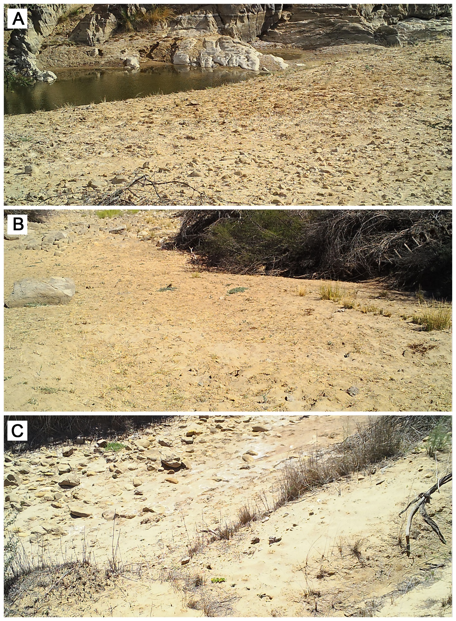**Figure 2: Study location of (A) Camera NPR1. (B) Camera NPR2. (C) Camera NPR3.**

Camera NPR1 faced north across and slightly upstream of the confluence of the Prins River at a large deep pool, with an overhanging face of sandstone above (Figure 2a). There was sparse cover of *Vachellia karroo* on the left bank, according to camera placement. Camera NPR2 (Figure 2b) was placed at a downstream exit of the canyon at the confluence of the Prins and Touws River at a smaller pool. Dense cover of *Vachellia karroo* occured on both banks. Camera NPR3 (Figure 2c) was positioned upstream of the confluence of the Prins and Touws rivers, at a pool similar in size to NPR2. Directly facing the camera is dense cover of *Vachellia karroo* on the left bank, a reedbed of *Phragmites australis* at the lower right bank grading into the *Vachellia karroo*.

## Data analysis

All images were downloaded from SD cards and entered into the software Timelapse2 (Greenberg, Godin and Whittington, 2019), designed for managing camera trap data while maximizing efficiency through rapid data-entry. For each photograph, the station, the temperature, the presence or absence of water, the date and time, and the species detected were recorded. Animals were identified down to species level through the use of Stuarts’ Field Guide to Mammals of Southern Africa (Struik Nature, 2015). Images of animals not identifiable due to lack of clarity were taken into consideration only for detection-based analysis. A relative abundance index (RAI) was calculated as the number of detections per species divided by sampling effort and then multiplied by 100 (thus, a measure of detections per 100 days of camera trapping). It is a common component of many camera trap studies and used for comparable results due to its simple formula, and the way in which it can be used in studies where true abundance would be complex or difficult to calculate (Palmer et al., 2018). RAIs can be used as a measure of population. Furthermore, Palmer *et al*. (2018) deduced that even under conditions with potential bias arising from imperfect detections, RAIs can predict relative abundance with accuracy.

Analyses were carried out in R version 3.5.0 (R Core Team, 2014). Species accumulation curves were plotted using the package vegan (Oksanen et al., 2019). Additionally, I calculated a separate curve for the overall study. This is a measure of the total number of species against the total sampling effort and demonstrates the rate at which new species are being detected within the sampling site (Ugland, Gray and Ellingsen, 2003). It allows the comparison of diversity across sites and is able to predict whether an environment has been sampled to an acceptable level of detection.

Analysis of species richness was carried out only on the subset of data with identified species. Photographs taken by motion-trigger were compared with photographs taken at hourly intervals to determine which had a higher detection rate and thus was more efficient and this was done through the use of a *t*-test. In order to investigate the relationship between whether an increase in water availability would result in an increase in species detection, an ANOVA was done of the time comparing detections during periods of water against detections during periods of water absence. A Chi square was done to examine if any difference in visitation occurred before and after a flooding event, such as that occurred in January 2018 (Figure 2). Diurnal variation in species detection was examined visually through the use of histograms generated using the package camtrapR (Niedballa et al., 2016).